**WEEK – 4**

**SPRING REST USING SPRING BOOT 3**

1. **Create a Spring Web Project using Maven**

**File name: SpringLearnApplication.java**

package com.cognizant.spring_learn;

import org.springframework.boot.SpringApplication;

import org.springframework.boot.autoconfigure.SpringBootApplication;

import org.slf4j.Logger;

import org.slf4j.LoggerFactory;

@SpringBootApplication

public class SpringLearnApplication {

private static final Logger LOGGER = LoggerFactory.getLogger(SpringLearnApplication.class);

public static void main(String[] args) {

SpringApplication.run(SpringLearnApplication.class, args);

System.out.println();

System.out.println("Tomcat started on port 8080 (http) with context path ''");

System.out.println("Started SpringLearnApplication");

System.out.println("STARTED");

LOGGER.info("STARTED");

}

}

**File name: SpringLearnApplicationTests.java**

package com.cognizant.spring_learn;

import org.junit.jupiter.api.Test;

import org.springframework.boot.test.context.SpringBootTest;

@SpringBootTest

class SpringLearnApplicationTests {

@Test

void contextLoads() {

}

}

**File name:pom.xml**

<project xmlns="http://maven.apache.org/POM/4.0.0"

xmlns:xsi="http://www.w3.org/2001/XMLSchema-instance"

xsi:schemaLocation="http://maven.apache.org/POM/4.0.0

http://maven.apache.org/xsd/maven-4.0.0.xsd">

<modelVersion>4.0.0</modelVersion>

<groupId>com.cognizant</groupId>

<artifactId>spring-learn</artifactId>

<version>0.0.1-SNAPSHOT</version>

<name>spring-learn</name>

<description>Spring Boot Web project</description>

<packaging>jar</packaging>

<parent>

<groupId>org.springframework.boot</groupId>

<artifactId>spring-boot-starter-parent</artifactId>

<version>3.2.0</version>

<relativePath/> <!-- lookup parent from repository -->

</parent>

<properties>

<java.version>17</java.version>

</properties>

<dependencies>

<!-- Spring Web -->

<dependency>

<groupId>org.springframework.boot</groupId>

<artifactId>spring-boot-starter-web</artifactId>

</dependency>

<!-- DevTools -->

<dependency>

<groupId>org.springframework.boot</groupId>

<artifactId>spring-boot-devtools</artifactId>

<scope>runtime</scope>

</dependency>

<!-- Test -->

<dependency>

<groupId>org.springframework.boot</groupId>

<artifactId>spring-boot-starter-test</artifactId>

<scope>test</scope>

</dependency>

</dependencies>

<build>

<plugins>

<plugin>

<groupId>org.springframework.boot</groupId>

<artifactId>spring-boot-maven-plugin</artifactId>

</plugin>

</plugins>

</build>

</project>

**OUTPUT:**

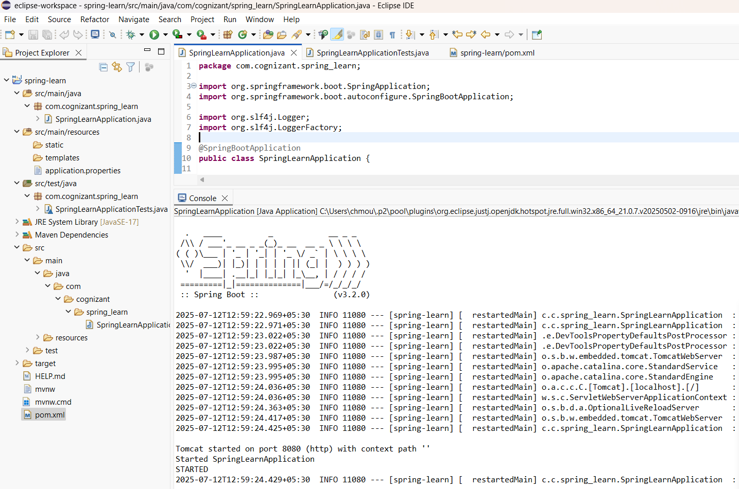

1. **Spring Core – Load Country from Spring Configuration XML**

**Package name:com.cognizant.spring_core_learn**

**File name: Country.java**

package com.cognizant.spring_core_learn;

import org.slf4j.Logger;

import org.slf4j.LoggerFactory;

public class Country {

private String code;

private String name;

private static final Logger LOGGER = LoggerFactory.getLogger(Country.class);

public Country() {

LOGGER.debug("Inside Country Constructor.");

}

public String getCode() {

LOGGER.debug("Getting code");

return code;

}

public void setCode(String code) {

LOGGER.debug("Setting code");

this.code = code;

}

public String getName() {

LOGGER.debug("Getting name");

return name;

}

public void setName(String name) {

LOGGER.debug("Setting name");

this.name = name;

}

@Override

public String toString() {

return "Country [code=" + code + ", name=" + name + "]";

}

}

**File name:pom.xml**

<project xmlns="http://maven.apache.org/POM/4.0.0"

xmlns:xsi="http://www.w3.org/2001/XMLSchema-instance"

xsi:schemaLocation="http://maven.apache.org/POM/4.0.0

http://maven.apache.org/xsd/maven-4.0.0.xsd">

<modelVersion>4.0.0</modelVersion>

<groupId>com.cognizant</groupId>

<artifactId>spring-core-learn</artifactId>

<version>1.0</version>

<dependencies>

<dependency>

<groupId>org.springframework</groupId>

<artifactId>spring-context</artifactId>

<version>5.3.36</version>

</dependency>

<dependency>

<groupId>org.slf4j</groupId>

<artifactId>slf4j-api</artifactId>

<version>2.0.12</version>

</dependency>

<dependency>

<groupId>org.slf4j</groupId>

<artifactId>slf4j-simple</artifactId>

<version>2.0.12</version>

</dependency>

</dependencies>

</project>

**File name: country.xml**

<?xml version="1.0" encoding="UTF-8"?>

<beans xmlns="http://www.springframework.org/schema/beans"

xmlns:xsi="http://www.w3.org/2001/XMLSchema-instance"

xsi:schemaLocation="http://www.springframework.org/schema/beans

http://www.springframework.org/schema/beans/spring-beans.xsd">

<bean id="country" class="com.cognizant.spring_core_learn.Country">

<property name="code" value="IN" />

<property name="name" value="India" />

</bean>

<bean id="countryList" class="java.util.ArrayList">

<constructor-arg>

<list>

<bean class="com.cognizant.spring_core_learn.Country">

<property name="code" value="IN"/>

<property name="name" value="India"/>

</bean>

<bean class="com.cognizant.spring_core_learn.Country">

<property name="code" value="US"/>

<property name="name" value="United States"/>

</bean>

<bean class="com.cognizant.spring_core_learn.Country">

<property name="code" value="DE"/>

<property name="name" value="Germany"/>

</bean>

<bean class="com.cognizant.spring_core_learn.Country">

<property name="code" value="JP"/>

<property name="name" value="Japan"/>

</bean>

</list>

</constructor-arg>

</bean>

</beans>

**Package name:com.cognizant.spring_core_learn**

**File name:Main.java**

package com.cognizant.spring_core_learn;

import org.springframework.context.ApplicationContext;

import org.springframework.context.support.ClassPathXmlApplicationContext;

import java.util.List;

public class Main {

public static void displayCountries() {

ApplicationContext context = new ClassPathXmlApplicationContext("country.xml");

List<Country> countries = (List<Country>)context.getBean("countryList");

for (Country c : countries) {

System.out.println(c);

}

}

public static void main(String[] args) {

System.out.println("Application Context Initialized");

displayCountries();

System.out.println("Application Execution Completed");

}

}

**OUTPUT:**

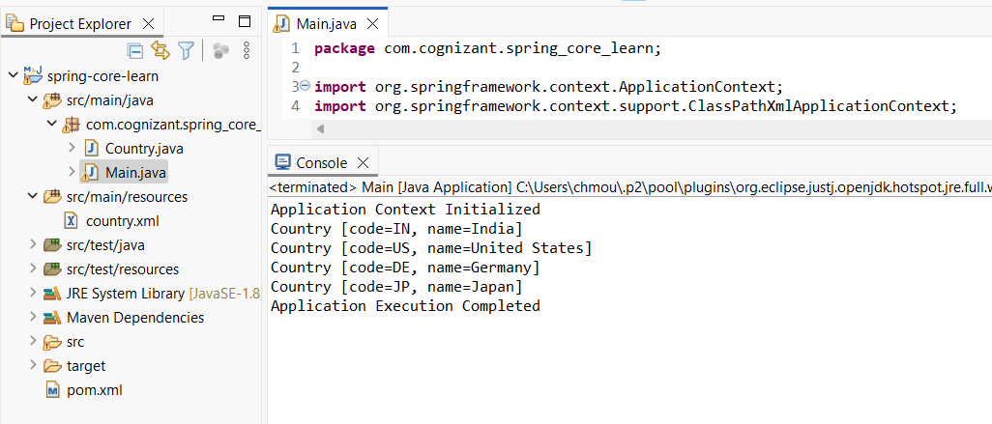

1. **Hello World RESTful Web Service**

**Package name:com.cognizant.spring_learn**

**File name:SpringLearnApplication.java**

package com.cognizant.spring_learn;

import org.springframework.boot.SpringApplication;

import org.springframework.boot.autoconfigure.SpringBootApplication;

@SpringBootApplication

public class SpringLearnApplication {

public static void main(String[] args) {

SpringApplication.run(SpringLearnApplication.class, args);

}

}

**Package name:com.cognizant.spring_learn.controller**

**File name:HelloController.java**

package com.cognizant.spring_learn.controller;

import org.slf4j.Logger;

import org.slf4j.LoggerFactory;

import org.springframework.web.bind.annotation.GetMapping;

import org.springframework.web.bind.annotation.RestController;

@RestController

public class HelloController {

private static final Logger LOGGER = LoggerFactory.getLogger(HelloController.class);

@GetMapping("/hello")

public String sayHello() {

LOGGER.info("START");

LOGGER.info("END");

return "Hello World!!";

}

}

**File name:application.properties**

server.port=8085

File name:pom.xml

<?xml version="1.0" encoding="UTF-8"?>

<project xmlns="http://maven.apache.org/POM/4.0.0" xmlns:xsi="http://www.w3.org/2001/XMLSchema-instance"

xsi:schemaLocation="http://maven.apache.org/POM/4.0.0 https://maven.apache.org/xsd/maven-4.0.0.xsd">

<modelVersion>4.0.0</modelVersion>

<parent>

<groupId>org.springframework.boot</groupId>

<artifactId>spring-boot-starter-parent</artifactId>

<version>3.5.3</version>

<relativePath/> <!-- lookup parent from repository -->

</parent>

<groupId>com.cognizant</groupId>

<artifactId>spring-learn</artifactId>

<version>0.0.1-SNAPSHOT</version>

<name>spring-learn</name>

<description>Demo project for Spring Boot</description>

<url/>

<licenses>

<license/>

</licenses>

<developers>

<developer/>

</developers>

<scm>

<connection/>

<developerConnection/>

<tag/>

<url/>

</scm>

<properties>

<java.version>17</java.version>

</properties>

<dependencies>

<dependency>

<groupId>org.springframework.boot</groupId>

<artifactId>spring-boot-starter-web</artifactId>

</dependency>

<dependency>

<groupId>org.springframework.boot</groupId>

<artifactId>spring-boot-starter-test</artifactId>

<scope>test</scope>

</dependency>

</dependencies>

<build>

<plugins>

<plugin>

<groupId>org.springframework.boot</groupId>

<artifactId>spring-boot-maven-plugin</artifactId>

</plugin>

</plugins>

</build>

</project>

**OUTPUT:**

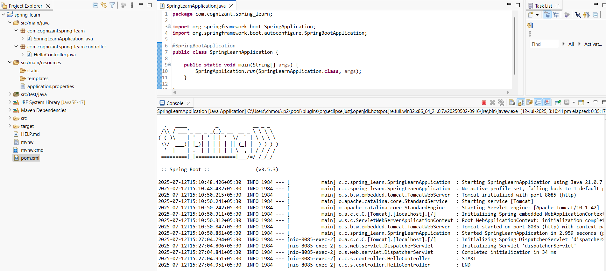

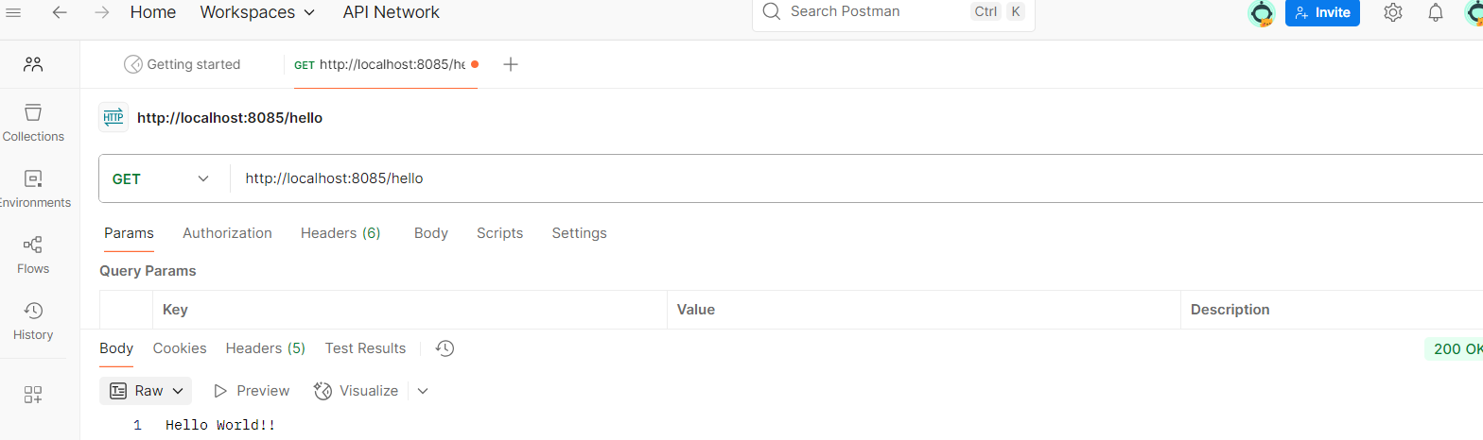

1. **REST - Country Web Service**

**Package name:com.cognizant.spring_learn**

**File name:SpringLearnApplication.java**

package com.cognizant.spring_learn;

import org.springframework.boot.SpringApplication;

import org.springframework.boot.autoconfigure.SpringBootApplication;

@SpringBootApplication

public class SpringLearnApplication {

public static void main(String[] args) {

SpringApplication.run(SpringLearnApplication.class, args);

}

}

**Package name:com.cognizant.spring_learn.contoller**

**File name:CountryController.java**

package com.cognizant.spring_learn.controller;

import org.springframework.web.bind.annotation.RequestMapping;

import org.springframework.web.bind.annotation.RestController;

import org.springframework.context.ApplicationContext;

import org.springframework.context.support.ClassPathXmlApplicationContext;

import com.cognizant.spring_learn.model.Country;

@RestController

public class CountryController {

@RequestMapping("/country")

public Country getCountryIndia() {

ApplicationContext context = new ClassPathXmlApplicationContext("country.xml");

Country country = (Country) context.getBean("in");

return country;

}

}

**File name:application.properties**

server.port=8083

**File name:pom.xml**

<?xml version="1.0" encoding="UTF-8"?>

<project xmlns="http://maven.apache.org/POM/4.0.0" xmlns:xsi="http://www.w3.org/2001/XMLSchema-instance"

xsi:schemaLocation="http://maven.apache.org/POM/4.0.0 https://maven.apache.org/xsd/maven-4.0.0.xsd">

<modelVersion>4.0.0</modelVersion>

<parent>

<groupId>org.springframework.boot</groupId>

<artifactId>spring-boot-starter-parent</artifactId>

<version>3.5.3</version>

<relativePath/> <!-- lookup parent from repository -->

</parent>

<groupId>com.cognizant</groupId>

<artifactId>spring-learn</artifactId>

<version>0.0.1-SNAPSHOT</version>

<name>spring-learn</name>

<description>Demo project for Spring Boot</description>

<url/>

<licenses>

<license/>

</licenses>

<developers>

<developer/>

</developers>

<scm>

<connection/>

<developerConnection/>

<tag/>

<url/>

</scm>

<properties>

<java.version>17</java.version>

</properties>

<dependencies>

<dependency>

<groupId>org.springframework.boot</groupId>

<artifactId>spring-boot-starter-web</artifactId>

</dependency>

<dependency>

<groupId>org.springframework.boot</groupId>

<artifactId>spring-boot-starter-test</artifactId>

<scope>test</scope>

</dependency>

</dependencies>

<build>

<plugins>

<plugin>

<groupId>org.springframework.boot</groupId>

<artifactId>spring-boot-maven-plugin</artifactId>

</plugin>

</plugins>

</build>

</project>

**Package name:com.cognizant.spring_learn.model**

**File name:Country.java**

package com.cognizant.spring_learn.model;

public class Country {

private String code;

private String name;

// Getters and Setters

public String getCode() {

return code;

}

public void setCode(String code) {

this.code = code;

}

public String getName() {

return name;

}

public void setName(String name) {

this.name = name;

}

}

**OUTPUT:**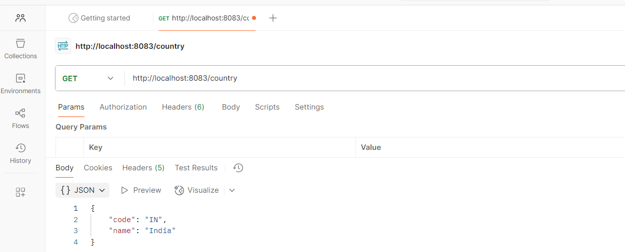

1. **REST - Get country based on country code**

**Package name:com.cognizant.spring_learn.model**

**File name:Country.java**

package com.cognizant.spring_learn.model;

public class Country {

private String code;

private String name;

// Constructors

public Country() {}

public Country(String code, String name) {

this.code = code;

this.name = name;

}

// Getters and Setters

public String getCode() {

return code;

}

public void setCode(String code) {

this.code = code.toUpperCase();

public String getName() {

return name;

}

public void setName(String name) {

this.name = name;

}

}

**Package name:com.cognizant.spring_learn.controller**

**File name:CountryController.java**

package com.cognizant.spring_learn.controller;

import org.springframework.beans.factory.annotation.Autowired;

import org.springframework.web.bind.annotation.*

import com.cognizant.spring_learn.model.Country;

import com.cognizant.spring_learn.service.CountryService

@RestController

public class CountryController {

@Autowired

private CountryService countryService;

@GetMapping("/country/{code}")

public Country getCountry(@PathVariable String code) throws Exception {

return countryService.getCountry(code);

}

}

**Package name:com.cognizant.spring_learn.service**

**File name:CountryService.java**

package com.cognizant.spring_learn.service

import java.util.List;

import java.util.Optional;

import org.springframework.context.ApplicationContext;

import org.springframework.context.support.ClassPathXmlApplicationContext;

import org.springframework.stereotype.Service;

import com.cognizant.spring_learn.model.Country;

@Service

public class CountryService {

public Country getCountry(String code) throws Exception {

ApplicationContext context = new ClassPathXmlApplicationContext("country.xml");

List<Country> countries = (List<Country>) context.getBean("countryList");

Optional<Country> result = countries.stream()

.filter(country -> country.getCode().equalsIgnoreCase(code))

.findFirst();

if (result.isPresent()) {

return result.get();

} else {

throw new Exception("Country not found for code: " + code);

}

}

}

**File name:application.properties**

server.port=8083

**File name:pom.xml**

<?xml version="1.0" encoding="UTF-8"?>

<project xmlns="http://maven.apache.org/POM/4.0.0" xmlns:xsi="http://www.w3.org/2001/XMLSchema-instance"

xsi:schemaLocation="http://maven.apache.org/POM/4.0.0 https://maven.apache.org/xsd/maven-4.0.0.xsd">

<modelVersion>4.0.0</modelVersion>

<parent>

<groupId>org.springframework.boot</groupId>

<artifactId>spring-boot-starter-parent</artifactId>

<version>3.5.3</version>

<relativePath/> <!-- lookup parent from repository -->

</parent>

<groupId>com.cognizant</groupId>

<artifactId>spring-learn</artifactId>

<version>0.0.1-SNAPSHOT</version>

<name>spring-learn</name>

<description>Demo project for Spring Boot</description>

<url/>

<licenses>

<license/>

</licenses>

<developers>

<developer/>

</developers>

<scm>

<connection/>

<developerConnection/>

<tag/>

<url/>

</scm>

<properties>

<java.version>17</java.version>

</properties>

<dependencies>

<dependency>

<groupId>org.springframework.boot</groupId>

<artifactId>spring-boot-starter-web</artifactId>

</dependency>

<dependency>

<groupId>org.springframework.boot</groupId>

<artifactId>spring-boot-starter-test</artifactId>

<scope>test</scope>

</dependency>

<dependency>

<groupId>org.springframework</groupId>

<artifactId>spring-context</artifactId>

</dependency>

</dependencies>

<build>

<plugins>

<plugin>

<groupId>org.springframework.boot</groupId>

<artifactId>spring-boot-maven-plugin</artifactId>

</plugin>

</plugins>

</build>

</project>

**File name:country.xml**

<?xml version="1.0" encoding="UTF-8"?>

<beans xmlns="http://www.springframework.org/schema/beans"

xmlns:xsi="http://www.w3.org/2001/XMLSchema-instance"

xsi:schemaLocation="http://www.springframework.org/schema/beans

http://www.springframework.org/schema/beans/spring-beans.xsd">

<bean id="in" class="com.cognizant.spring_learn.model.Country">

<property name="code" value="IN" />

<property name="name" value="India" />

</bean>

<bean id="us" class="com.cognizant.spring_learn.model.Country">

<property name="code" value="US" />

<property name="name" value="United States" />

</bean>

<bean id="countryList" class="java.util.ArrayList">

<constructor-arg>

<list>

<ref bean="in" />

<ref bean="us" />

</list>

</constructor-arg>

</bean>

</beans>

**Package name:com.cognizant.spring_learn**

**File name:SpringLearnApplication.java**

package com.cognizant.spring_learn;

import org.springframework.boot.SpringApplication;

import org.springframework.boot.autoconfigure.SpringBootApplication;

@SpringBootApplication

public class SpringLearnApplication {

public static void main(String[] args) {

SpringApplication.run(SpringLearnApplication.class, args);

}

}

**OUTPUT:**

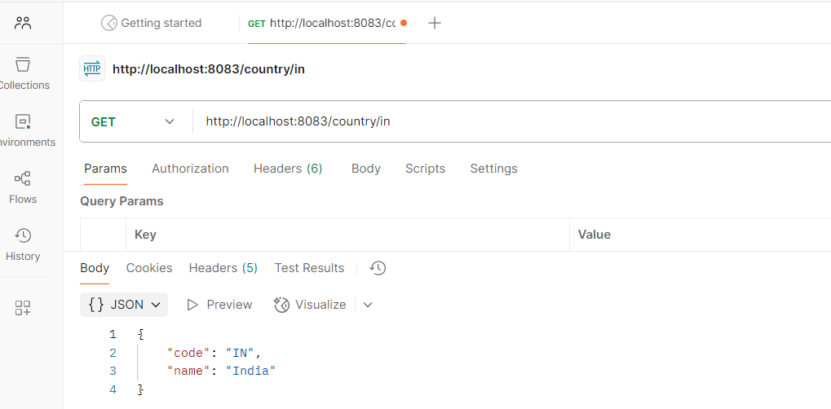

1. **Create authentication service that returns JWT**

**Package name:com.example.jwt_auth.config**

**File name:SecurityConfig.java**

package com.example.jwt_auth.config;

import org.springframework.context.annotation.Bean;

import org.springframework.context.annotation.Configuration;

import org.springframework.security.core.userdetails.User;

import org.springframework.security.core.userdetails.UserDetails;

import org.springframework.security.core.userdetails.UserDetailsService;

import org.springframework.security.provisioning.InMemoryUserDetailsManager;

@Configuration

public class SecurityConfig {

@Bean

public UserDetailsService userDetailsService() {

UserDetails user = User.builder()

.username("user")

.password("{noop}pwd") // No encoding for development

.roles("USER")

.build();

return new InMemoryUserDetailsManager(user);

}

}

**Package name:com.example.jwt_auth.controller**

**File name:AuthController.java**

package com.example.jwt_auth.controller;

import com.example.jwt_auth.util.JwtUtil;

import org.springframework.beans.factory.annotation.Autowired;

import org.springframework.security.core.Authentication;

import org.springframework.web.bind.annotation.*;

import java.util.*;

@RestController

public class AuthController {

@Autowired

private JwtUtil jwtUtil;

@GetMapping("/authenticate")

public Map<String, String> authenticate(Authentication auth) {

String token = jwtUtil.generateToken(auth.getName());

return Collections.singletonMap("token", token);

}

}

**Package name:com.example.jwt_auth.util**

**File name: JwtUtil.java**

package com.example.jwt_auth.util;

import io.jsonwebtoken.Jwts;

import io.jsonwebtoken.security.Keys;

import io.jsonwebtoken.SignatureAlgorithm;

import org.springframework.stereotype.Component;

import java.util.Date;

import java.security.Key;

@Component

public class JwtUtil {

private final Key secretKey = Keys.hmacShaKeyFor("12345678901234567890123456789012".getBytes());

public String generateToken(String username) {

return Jwts.builder()

.setSubject(username)

.setIssuedAt(new Date())

.setExpiration(new Date(System.currentTimeMillis() + 1000*60*5))

.signWith(secretKey, SignatureAlgorithm.HS256)

.compact();

}

}

**Package name:com.example.jwt_auth**

**File name: JwtAuthApplication.java**

package com.example.jwt_auth;

import org.springframework.boot.SpringApplication;

import org.springframework.boot.autoconfigure.SpringBootApplication;

@SpringBootApplication

public class JwtAuthApplication {

public static void main(String[] args) {

SpringApplication.run(JwtAuthApplication.class, args);

}

}

**File name: application.properties**

spring.application.name=jwt-auth

server.port=8080

logging.level.org.springframework.web=DEBUG

logging.level.com.example.jwt_auth=DEBUG

**File name:pom.xml**

<?xml version="1.0" encoding="UTF-8"?>

<project xmlns="http://maven.apache.org/POM/4.0.0" xmlns:xsi="http://www.w3.org/2001/XMLSchema-instance"

xsi:schemaLocation="http://maven.apache.org/POM/4.0.0 https://maven.apache.org/xsd/maven-4.0.0.xsd">

<modelVersion>4.0.0</modelVersion>

<parent>

<groupId>org.springframework.boot</groupId>

<artifactId>spring-boot-starter-parent</artifactId>

<version>3.5.3</version>

<relativePath/> <!-- lookup parent from repository -->

</parent>

<groupId>com.example</groupId>

<artifactId>jwt-auth</artifactId>

<version>0.0.1-SNAPSHOT</version>

<name>jwt-auth</name>

<description>Demo project for Spring Boot</description>

<url/>

<licenses>

<license/>

</licenses>

<developers>

<developer/>

</developers>

<scm>

<connection/>

<developerConnection/>

<tag/>

<url/>

</scm>

<properties>

<java.version>17</java.version>

</properties>

<dependencies>

<dependency>

<groupId>org.springframework.boot</groupId>

<artifactId>spring-boot-starter-security</artifactId>

</dependency>

<dependency>

<groupId>org.springframework.boot</groupId>

<artifactId>spring-boot-starter-web</artifactId>

</dependency>

<dependency>

<groupId>org.springframework.boot</groupId>

<artifactId>spring-boot-starter-test</artifactId>

<scope>test</scope>

</dependency>

<dependency>

<groupId>org.springframework.security</groupId>

<artifactId>spring-security-test</artifactId>

<scope>test</scope>

</dependency>

<dependency>

<groupId>io.jsonwebtoken</groupId>

<artifactId>jjwt-api</artifactId>

<version>0.11.5</version>

</dependency>

<dependency>

<groupId>io.jsonwebtoken</groupId>

<artifactId>jjwt-impl</artifactId>

<version>0.11.5</version>

<scope>runtime</scope>

</dependency>

<dependency>

<groupId>io.jsonwebtoken</groupId>

<artifactId>jjwt-jackson</artifactId> <!-- or jjwt-gson -->

<version>0.11.5</version>

<scope>runtime</scope>

</dependency>

</dependencies>

<build>

<plugins>

<plugin>

<groupId>org.springframework.boot</groupId>

<artifactId>spring-boot-maven-plugin</artifactId>

</plugin>

</plugins>

</build>

</project>

**OUTPUT:**

